|  |  |  |
| --- | --- | --- |
| **CL-1002 Programming Fundamentals** | **LAB - 01**  **Problem solving with sequential structure using Scratch** | |
| **NATIONAL UNIVERSITY OF COMPUTER AND EMERGING SCIENCES**  **Fall 2023**  **NATIONAL UNIVERSITY OF COMPUTER AND EMERGING SCIENCES**  **NATIONAL UNIVERSITY OF COMPUTER AND EMERGING SCIENCES**  **NATIONAL UNIVERSITY OF COMPUTER AND EMERGING SCIENCES** | |  |

**Introduction**

Visual Programming Language (VPL) is an application development environment designed on a graphical block-based programming model.

**Scratch Interface**

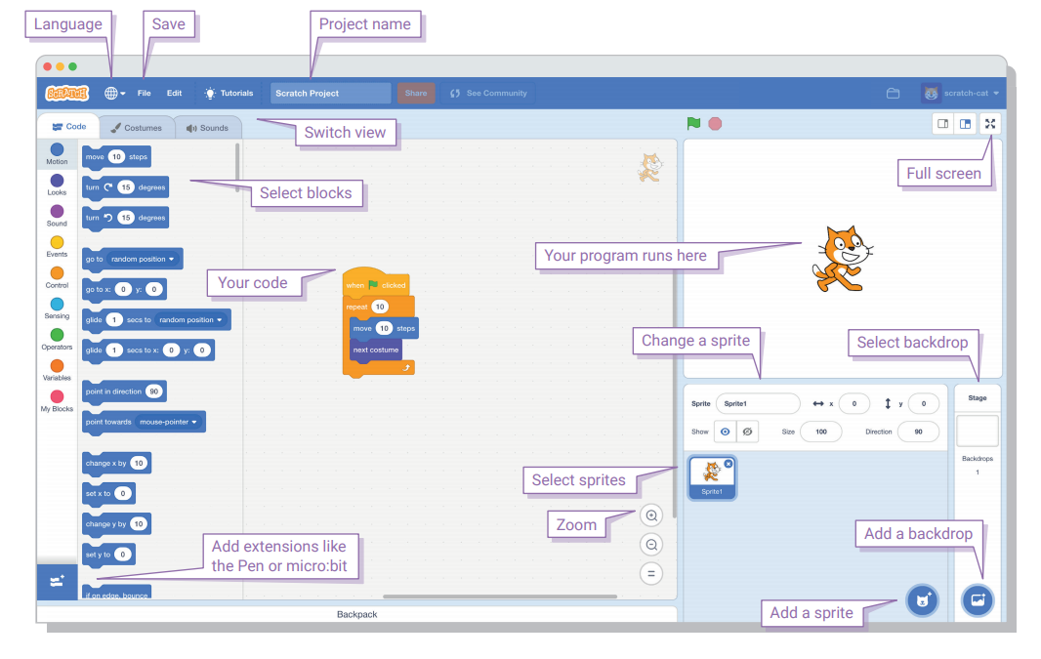

**Example#1: Writing our first script in a scratch to print “Hello” to the world.**

#include <stdio.h>

int main()

{

printf(“Hello World”);

}

**Example#2: Prompting your Name and printing “Hello” to your Name.**

**Script: Output:**

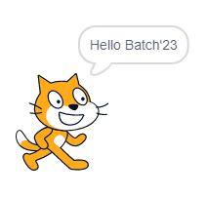

**Example#3: Asking your Name and saying by speaking “Hello” to your Name.**

**Script:**

**Example#4: Setting Grid Backdrop and moving spirit onto the xy-axis and draw square on the screen.**

**Script: Output:**

**Example#5: Write a script of input two numbers, add two numbers and print the sum of numbers.**

**Script: Output:**

**Example#6: Write a script to find an area of circle**

**Script: Output:**

**Example#7: Conversation between two scripts when clicked on the spirit.**

**Spirit#1**

**Spirit#2**

**EXERCISE#1**

**QUESTION#1**Make a simple calculator which performs basic arithmetic operations of mathematics such as addition, subtraction, division and multiplication using scratch.

**QUESTION#2**

Ahmed’s ball container is 20 centimeters tall, 10 centimeters long and 10 centimeters wide. Find the volume of container using scratch.

**QUESTION#3**

Calculate the hypotenuse of a right angled triangle with given two sides using scratch.

**QUESTION#4**

A Fat Brain pipsquigz is on sale for 20% off the original price. The original price is Rs. 1500. Using scratch calculate and print the sale price.

**QUESTION#5**

A bus leaves the university to take students on a field trip. The bus travels 10 kilometers south, 10 kilometers west, another 5 kilometers south and 15 kilometers north with the fuel consumption of 2 liters/km. Using scratch calculate how many kilometers it has covered and how much fuel it has consumed on a field trip?

**QUESTION#6**

For 4 weeks, Ali volunteered as a helper for swimming classes. The first week, he volunteered for 8 hours. He volunteered for 12 hours in the second week, and another 12 hours in the third week. The fourth week, he volunteered for 9 hours. Using scratch calculate how many hours did he volunteer per week, on average?

**QUESTION#7**

Famous math’s Square roots can also be used to find the distance between two points in a 2-dimensional or 3-dimensional system for movie or video game production. We have the formula for the distance D between two points (x1, y1) and (x2, y2) in 2 dimensions which is given by:

**D = √((x2 – x1)2 + (y2 – y1)2)**

Find the distance D using scratch.